­ClubUML: Rationale Management

UI Design Document

Author(s): Lauren DiCristofaro

Draft 1 (2/3/2014)

# Introduction

This document describes the User Interface for the first ClubUML Rationale Management feature as described by RM1 in the associated Use Cases[1].

## About this document

This document is divided into the following sections:

* *Structure and Navigation* describes the structure of the new feature.
* *Page and Element Descriptions* provides a more in depth explanation of relevant UI components

## References

Refer also to the following documents:

[1] Use case taken from: [Rationale Management Use Case Document](https://blackboard.neu.edu/courses/1/CSYE7945.31372.201430/db/_2986338_1/Rationale%20Management%20Use%20Cases.pdf) dated 1/22/2014

[2] This document uses template elements from: <http://infodesign.com.au/wp-content/uploads/uidocumentation.pdf> on 2/2/2014

## Graphic treatment

This document uses UI elements aligned with the current style of the ClubUML application. This promotes a more realistic evaluation of the UI before it needs to be implemented. The images below are intended as a close approximation of details in the final product, but they are still malleable, and there is room for reasonable alterations during implementation.

# Structure and Navigation

Because this document only describes a feature to be added, the navigation is a very simple addition to the ClubUML application.

Structure and Navigation Diagram: The numbers below reference UI elements discussed in this document

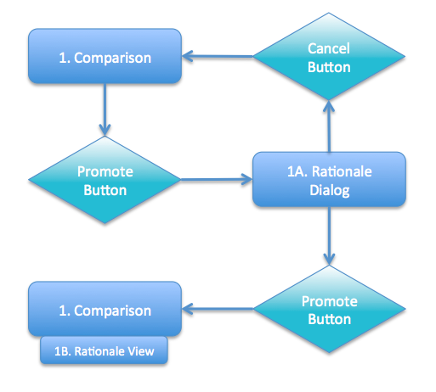

## Navigation

There are two new elements, the Rationale Dialog (1A) and the Rationale View (1B). These can both be accessed from the existing Comparison (1) page. Navigating from the existing Comparison page (1), the user can click a “Promote” button to promote a diagram. This should pop up a Rationale Dialog (1A) box. At this point, the user can click “Cancel” to dismiss the Rationale Dialog and go back to the initial Comparison screen. Alternatively, the user can fill in the relevant rationale details and click “Promote” in the Rationale Dialog. This “Promote” button dismisses the dialog and brings them back to the Comparison screen, which displays a Rationale View (1B) sub-view.

# Page and Element Descriptions

The page and element descriptions give a detailed explanation of the user interaction and navigation involved with each element and how they implement the requirements of use case RM1.

## 1. Comparison Page

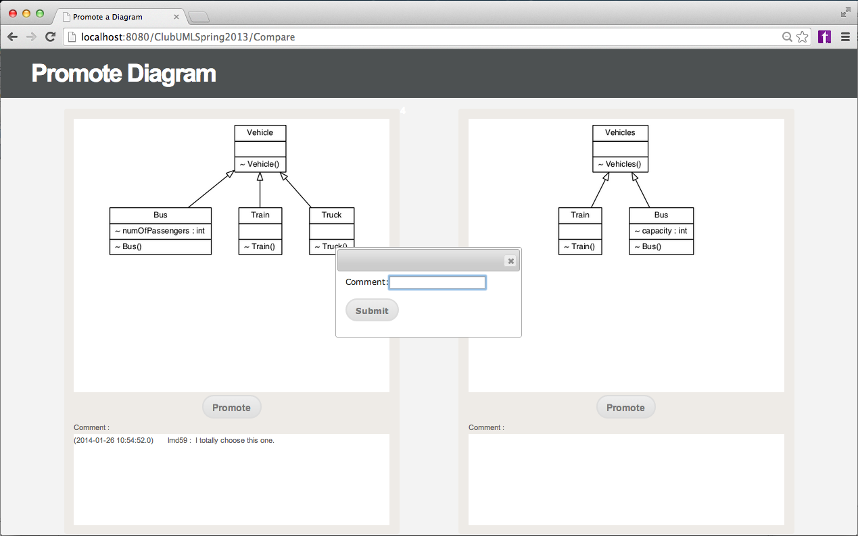

The comparison page is the assumed starting point of RM1. The current comparison page shows two diagrams that the user is comparing with comments and a comparison report shown below. The user can choose to promote either diagram. When the user clicks promote, a dialog box pops up and prompts for a comment to associate with the promotion. In order to satisfy RM1, the “Promote” button should instead pop up the Rationale Dialog box.

## 1A. Rationale Dialog

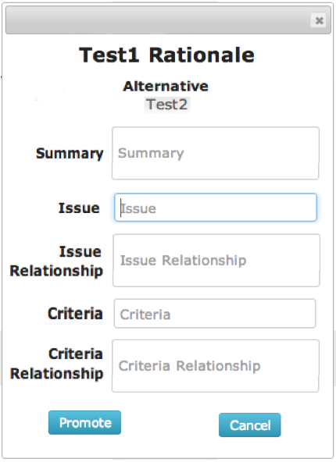**Sample Input**:

**Diagram A Rationale**

**Alternative**: **Diagram B**

**Summary**: Diagram A is clearly the better diagram because it includes concept Z…

**Issue**: Bug #5

**Issue** **Relationship**: Diagram A more effectively prevents Bug #5 because it has class X...

**Criteria**: Requirement #6

**Criteria** **Relationship**: Diagram A better addresses Requirement #6 because it has class Y...

The Rationale Dialog box is intended to replace the comment dialog box. It should prompt the user for more structure reasoning behind the decision to promote one diagram over another. The above image shows a detailed view of the extended rationale prompt, which includes the following elements:

* **Title**: Large static text that shows the dialog purpose and references the title of the diagram to be promoted (“Test 1” in this case).
* **Alternative**: Static text name of other diagram from the Comparison view.
* **Summary**: Larger text input box to allow for multi-sentence input
* **Issue**: Small text input box meant for the issue name.
* **Issue** **Relationship**: Larger text input box that prompts for an explanation of how the issue relates to the superiority of the chosen diagram.
* **Criteria**: Small text input box meant for the criteria name.
* **Criteria** **Relationship**: Larger text input box that prompts for an explanation of how the criteria relates to the superiority of the chosen diagram.
* **Promote** **Button**: Saves input and dismisses dialog box.
* **Cancel** **Button**: Discards input and dismisses dialog box.

## 1B. Rationale View

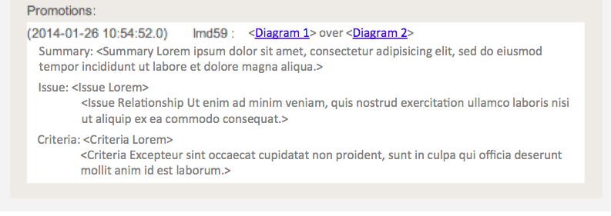

The Rationale View is a sub-view meant to replace the comment sub-view in the Comparison View. This view should be populated after a user saves their Rationale Dialog box input by clicking the “Promote” button. This information is persistent, so the view should also be displayed on the comparison screen for all previously saved promotions.

The Rationale View shows details about the promotion and the rationale behind it. This includes the date of the promotion and the user name of the promoter along with all user input data from the Rationale Dialog. Ideally, the relevant diagram names should link to the associated diagram’s Display Diagram detail view, and the text should display in a user-friendly format that is easy to read.